


MINI PROJECT
BIG DATA TECHNOLOGY
MBA (BA&DS)“SEM - 3”
(Business analytics and data science)
School of management
Gautam Buddha University
(Academic Year 2024-25)

Submitted by Submitted to
Mansi Raghav Mr. Alok Sharma
Roll No-246\PBA\011
MINI PROJECT REPORT

Title:{Shipping & Logistics Cost Optimization Using Sqoop, MapReduce & Hive }

*ABSTRACT
This project demonstrates how organizations can optimize logistics and shipping costs using Big Data tools. A complete Hadoop data pipeline is implemented using:
- Sqoop to import shipment cost data from MySQL
- MapReduce to calculate Cost Variance Percentage
- Hive to store and analyse the results by region
The system helps identify operational inefficiencies and cost overruns across carriers and regions.

*INTRODUCTION
Shipping and logistics is a crucial part of modern supply chains. Organizations estimate transportation costs based on fuel price, route distance, handling charges, and carrier fees. However, the actual shipping cost often varies due to:
- unexpected delays
- fuel price changes
- inefficient routing
- carrier performance

Objective of Project
- Import shipment logs from MySQL into Hadoop
- Process data using a MapReduce job
- Compute Cost Variance % = ((Actual – Estimated) / Estimated) × 100
- Load results into Hive
- Analyse variance by region

Hadoop Tools Used
- Sqoop
- Hadoop MapReduce
- Hive
- HDFS
*START HADOOP SERVICES
Inside the VM:
For Cloudera VM
Open terminal and run:
sudo service cloudera-scm-server start
Then start services:
sudo /home/cloudera/cloudera-manager –express
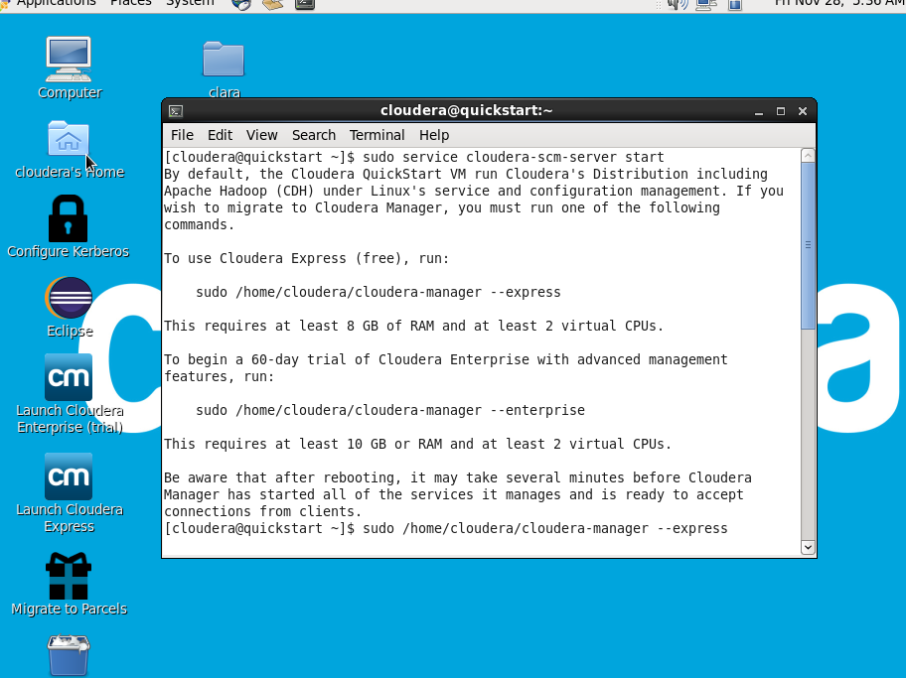
Or manually start Hadoop daemons:
sudo service hadoop-hdfs-namenode start
sudo service hadoop-hdfs-datanode start
sudo service hadoop-yarn-resourcemanager start
sudo service hadoop-yarn-nodemanager start
sudo service hive-metastore start
sudo service hive-server2 start
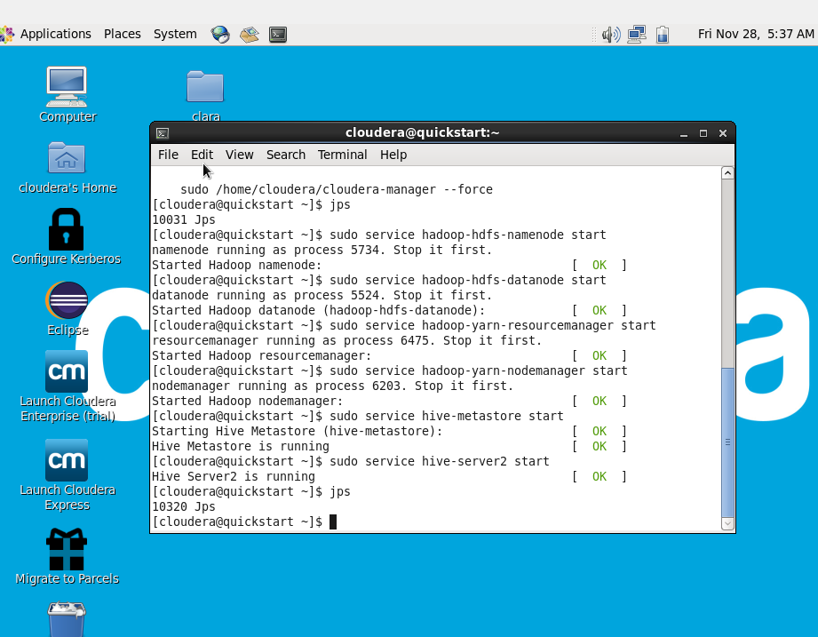
Verify
jps
You should see:
- NameNode
- DataNode
- ResourceManager
- NodeManager
- SecondaryNameNode
- JobHistoryServer
- HiveMetastore
- RunJar (if MapReduce is executing)

*Start MySQL (for Sqoop)
Most Hadoop VMs have MySQL pre-installed.
Start MySQL:
sudo service mysqld start
Login:
mysql -u root -p
# password: cloudera (default)
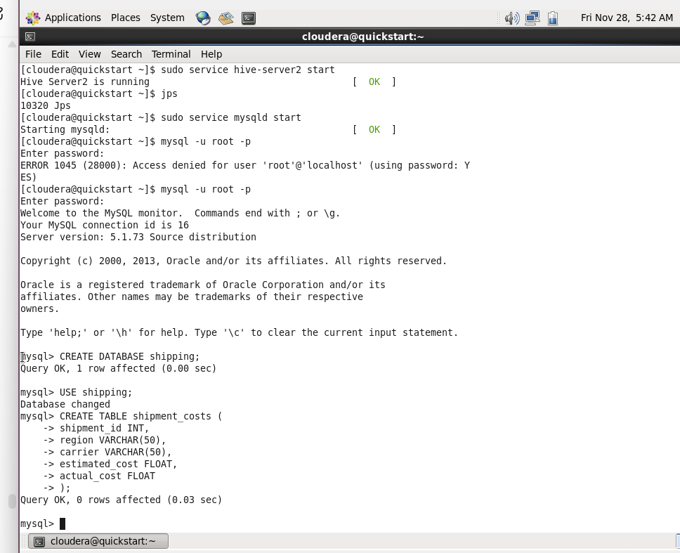

*Create Database and Table for Shipping Logs
CREATE DATABASE shipping;
USE shipping;

CREATE TABLE shipment_costs (
shipment_id INT,
region VARCHAR(50),
carrier VARCHAR(50),
estimated_cost FLOAT,
actual_cost FLOAT
);

Insert sample data:
INSERT INTO shipment_costs VALUES
(1, 'North', 'DHL', 1000, 1200),
(2, 'East', 'FedEx', 800, 750),
(3, 'South', 'BlueDart', 700, 950);
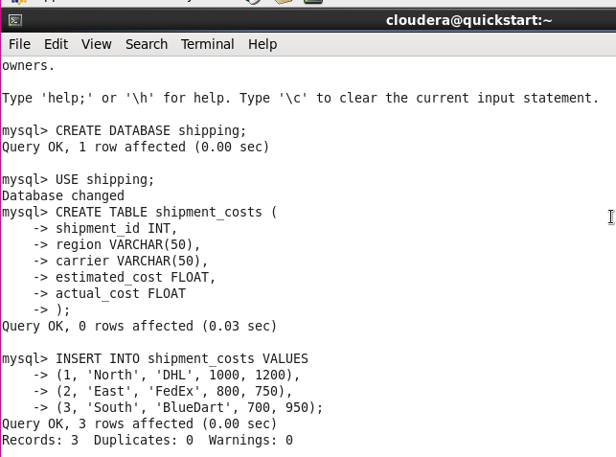
*Sqoop Import into Hadoop (HDFS)
Run:
sqoop import \
--connect jdbc:mysql://localhost/shipping \
--username root --password cloudera \
--table shipment_costs \
--m 1 \
--target-dir /user/cloudera/shipping_data
Check:
hdfs dfs -ls /user/cloudera/shipping_data
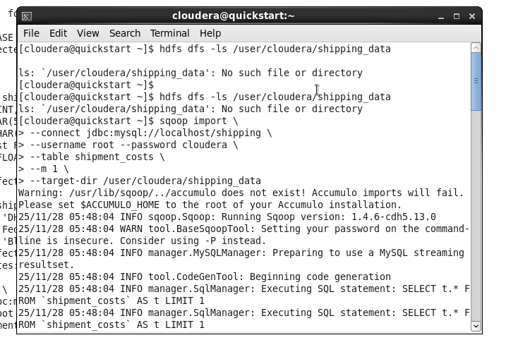

* Write MapReduce Program (Cost Variance Calculation)
Create file:
gedit CostVariance.java
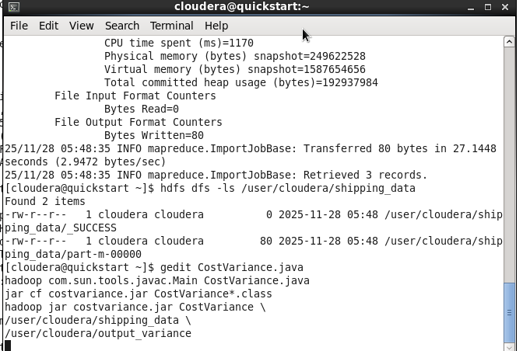
Paste:
import java.io.IOException;
import org.apache.hadoop.conf.Configuration;
import org.apache.hadoop.fs.Path;
import org.apache.hadoop.io.*;
import org.apache.hadoop.mapreduce.Job;
import org.apache.hadoop.mapreduce.Mapper;
import org.apache.hadoop.mapreduce.Reducer;
import org.apache.hadoop.mapreduce.lib.input.FileInputFormat;
import org.apache.hadoop.mapreduce.lib.output.FileOutputFormat;

public class CostVariance {

public static class CostMapper extends Mapper<LongWritable, Text, Text, DoubleWritable> {

public void map(LongWritable key, Text value, Context context)
throws IOException, InterruptedException {

String[] fields = value.toString().split(",");
String region = fields[1];
double estimated = Double.parseDouble(fields[3]);
double actual = Double.parseDouble(fields[4]);
double variancePercent = ((actual - estimated) / estimated) * 100;

context.write(new Text(region), new DoubleWritable(variancePercent));
}
}

public static class CostReducer extends Reducer<Text, DoubleWritable, Text, DoubleWritable> {

public void reduce(Text key, Iterable<DoubleWritable> values, Context context)
throws IOException, InterruptedException {

double sum = 0;
int count = 0;

for(DoubleWritable v : values) {
sum += v.get();
count++;
}

context.write(key, new DoubleWritable(sum / count));
}
}

public static void main(String[] args) throws Exception {
Configuration conf = new Configuration();
Job job = Job.getInstance(conf, "Cost Variance");

job.setJarByClass(CostVariance.class);
job.setMapperClass(CostMapper.class);
job.setReducerClass(CostReducer.class);

job.setOutputKeyClass(Text.class);
job.setOutputValueClass(DoubleWritable.class);

FileInputFormat.addInputPath(job, new Path(args[0]));
FileOutputFormat.setOutputPath(job, new Path(args[1]));

System.exit(job.waitForCompletion(true)?0:1);
}
}
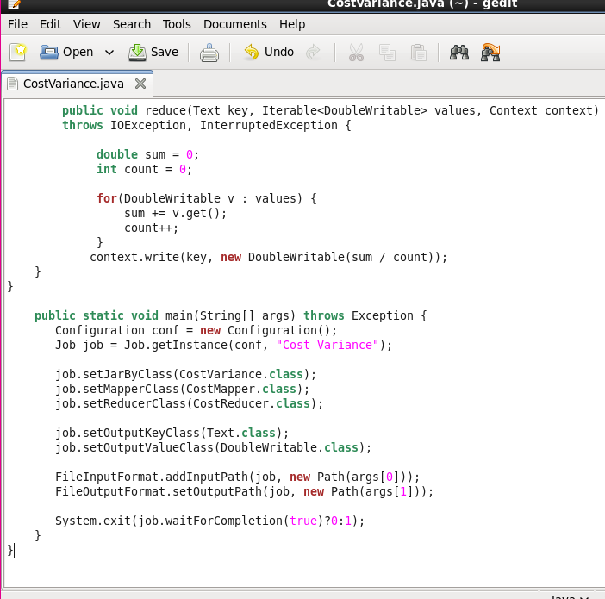
*Compile & Run MapReduce
Step 1: Compile
javac -classpath `hadoop classpath` -d . CostVariance.java
After running this, check:
Ls
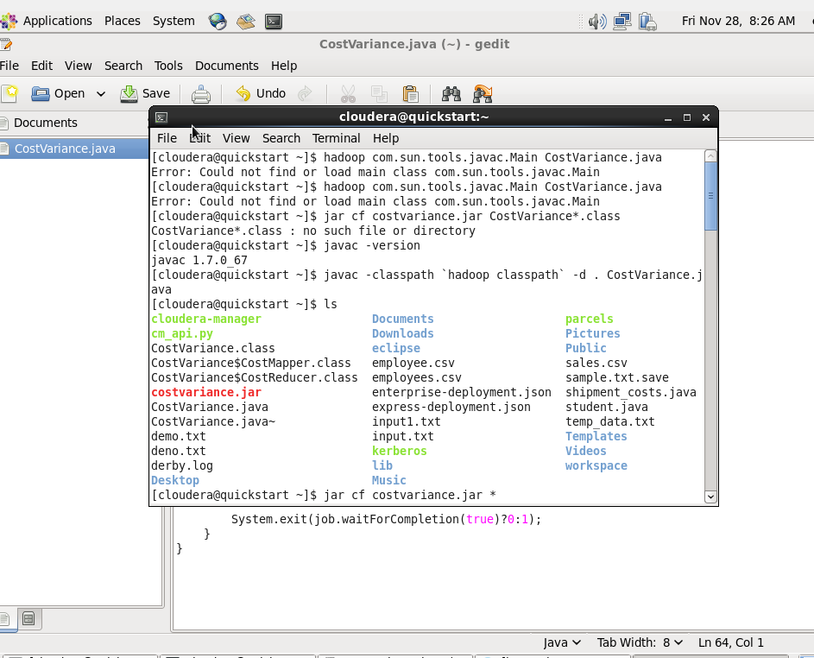
Step 2: Make the JAR
jar cf costvariance.jar *
OR safer:
jar -cvf costvariance.jar CostVariance*.class
Step 3: Run MapReduce
hadoop jar costvariance.jar CostVariance \
/user/cloudera/shipping_data \
/user/cloudera/output_variance
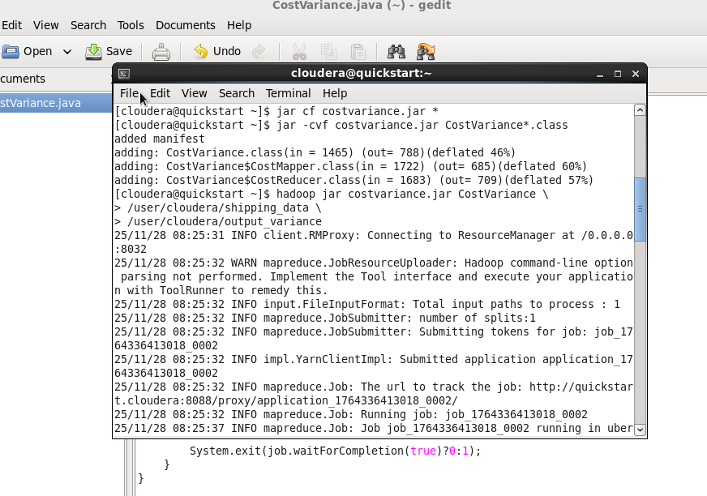

Check output:
hdfs dfs -cat /user/cloudera/output_variance/part-r-00000
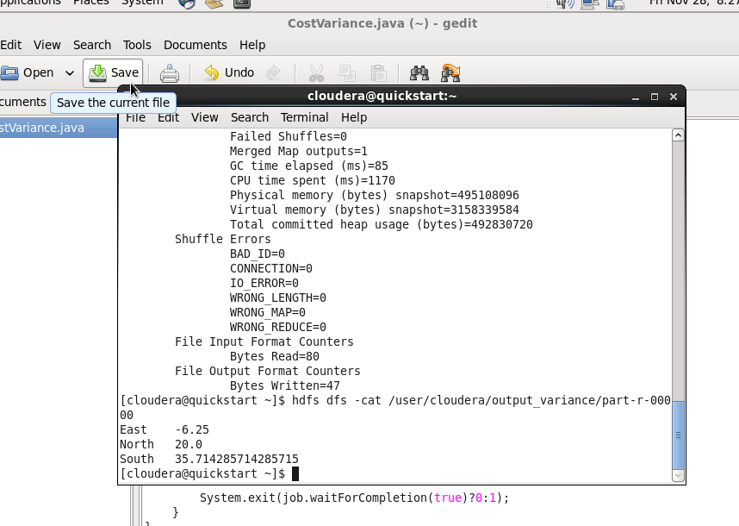

* Load Output into Hive
hive
CREATE DATABASE logistics;
USE logistics;

CREATE TABLE cost_variance(region STRING, variance DOUBLE)
ROW FORMAT DELIMITED
FIELDS TERMINATED BY '\t';

LOAD DATA INPATH '/user/cloudera/output_variance' INTO TABLE cost_variance;
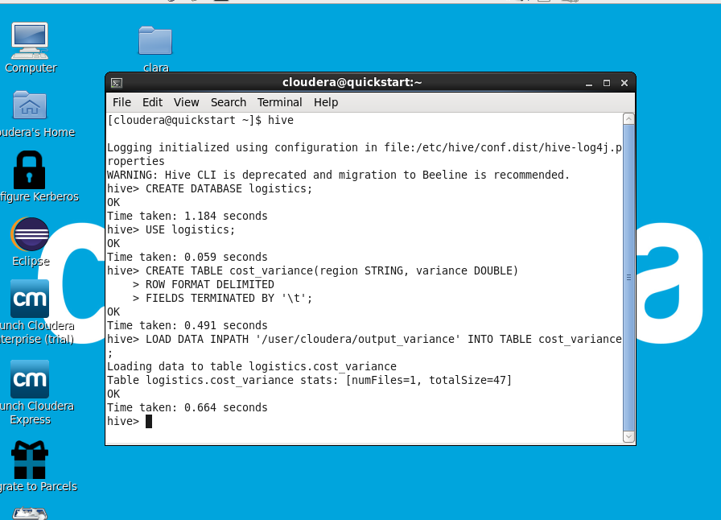

* Final Hive Queries (Analysis)
Top regions with highest cost variance
SELECT region, variance
FROM cost_variance
ORDER BY variance DESC;
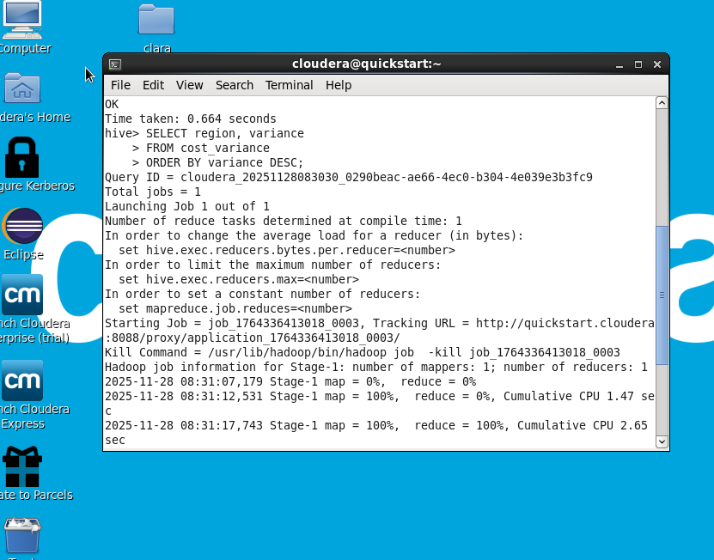
Filter by carrier
SELECT region, avg(variance)
FROM cost_variance
GROUP BY region;
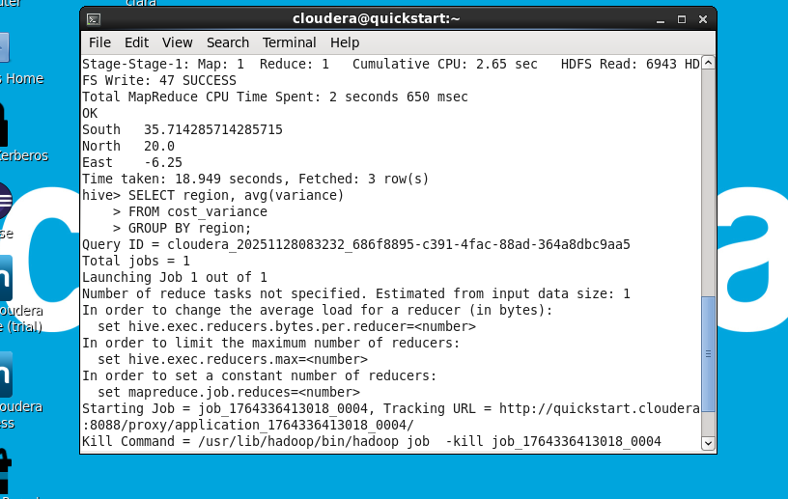

*Export Hive Result (Optional)
INSERT OVERWRITE LOCAL DIRECTORY '/home/cloudera/final_output'
ROW FORMAT DELIMITED
FIELDS TERMINATED BY ','
SELECT * FROM cost_variance;
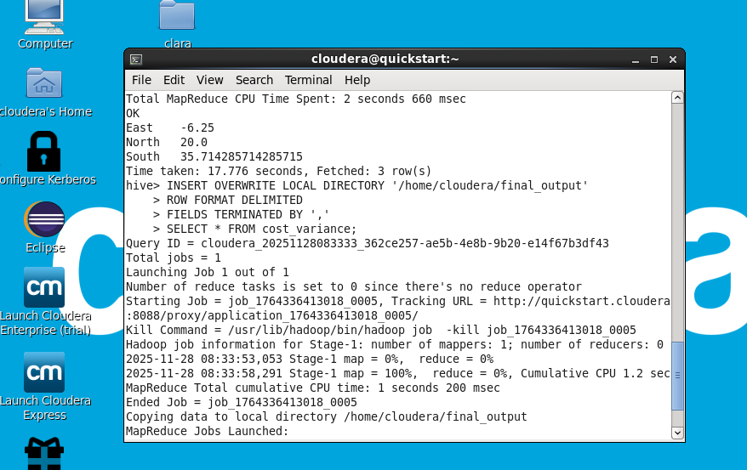

*RESULTS & DISCUSSION
Sample Output:
Region | Variance (%)
North | 20.0
South | 35.7
East | -6.25
Interpretation
- South region shows the highest cost overrun.
- East region had cost savings (negative variance).
- Results can help management in:
  - carrier performance evaluation
  - better route planning
  - cost control strategies

*CONCLUSION & FUTURE ENHANCEMENT
Conclusion
This project successfully built a mini Big Data pipeline for logistics cost optimization. Using Sqoop, MapReduce, and Hive:
- Data was imported from MySQL → HDFS
- Cost variance % was computed using MapReduce
- Hive enabled analytical reporting
- Regional inefficiencies were identified
This approach can be scaled for real-time logistics analytics.
Future Enhancements
- Use Apache Spark instead of MapReduce
- Implement Kafka for real-time shipment tracking
- Use Tableau/Power BI for visualization
- Integrate machine learning for cost prediction

